Target Graph

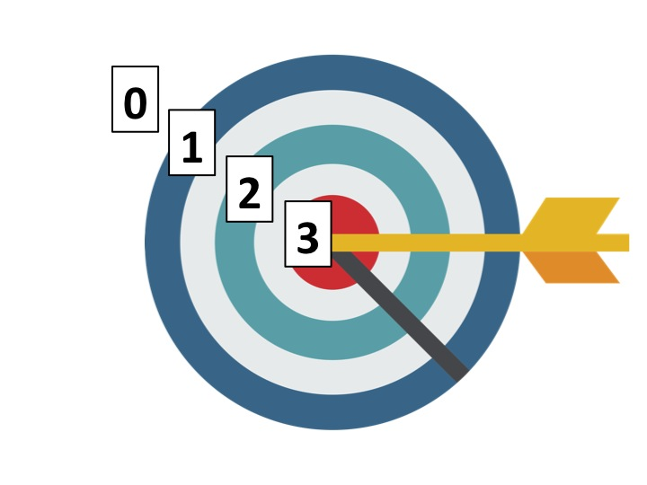
MSA Reading- BCR Rubric

Score 3:
The response demonstrates an understanding of the complexities of the text.
- Addresses the demands of the question
- Effectively uses text-relevant information to clarify or extend understanding

Score 2:
The response demonstrates a general understanding of the text.
- Partially addresses the demands of the question
- Uses text-relevant information to show understanding

Score 1:
The response demonstrates a minimal understanding of the text.
- Minimally addresses the demands of the question
- Uses minimal information to show some understanding of the text in relation to the question

Score 0:
The response is completely incorrect, irrelevant to the question, or missing.

