RS Notes: Transforming the Roman World

New Germanic Kingdoms
- Germanic peoples began moving into the lands of the Roman Empire around the 3rd Century
  - Visigoths occupied Spain and Italy(Ostrogoths later took control)
  - Angles and Saxons- Britain
  - Saxons- Northern Germany
  - Franks- France
- Longest lasting was the K. of the Franks
  - Clovis established it around 500
    - Strong military leader
    - First Germanic ruler to convert to Christianity- won support of Roman Catholic Church
The Role of the Church
- By the 4th C, Christianity had become the supreme religion of the Roman Empire
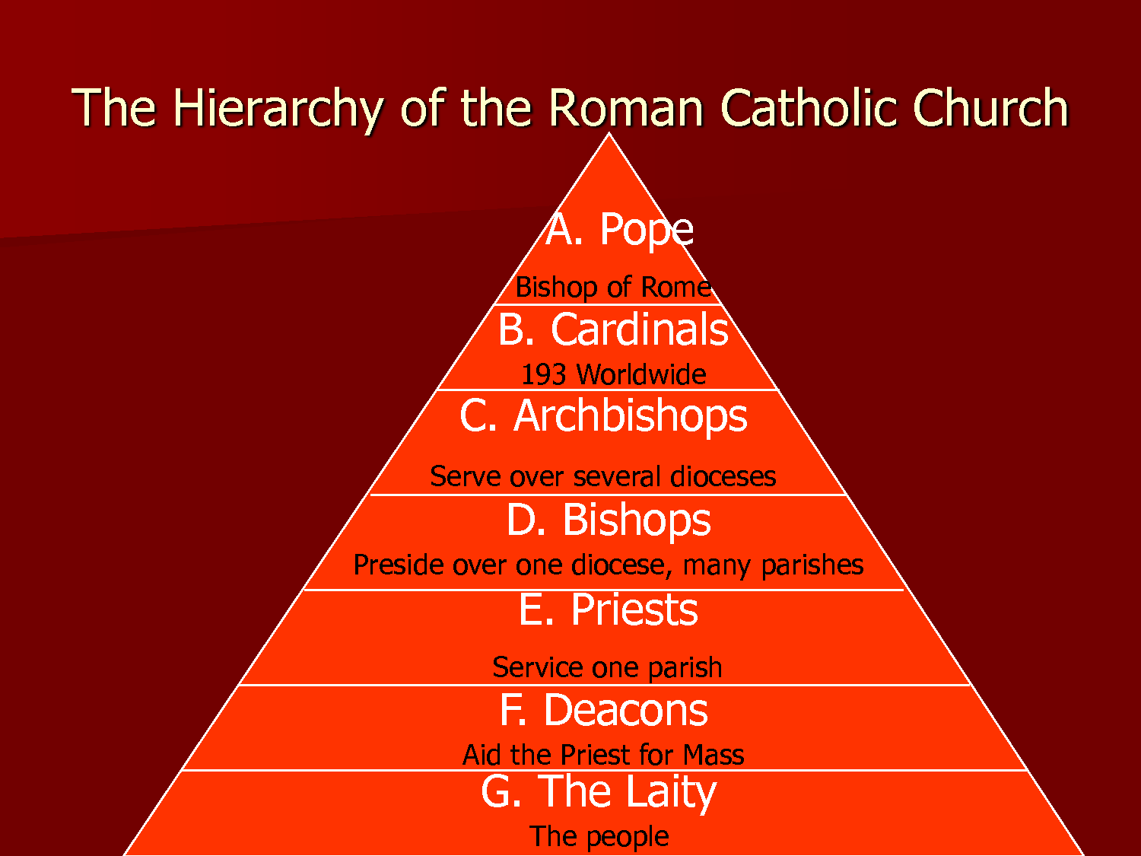
  - Developed a system of organization
    - Priests head local parishes
    - A group of parishes=bishopric
      - Headed by a bishop
    - A group of bishoprics=archbishopric
      - Headed by an archbishop
    - The Bishop of Rome came to claim he was the leader of the Roman Catholic Church (the Pope)
      - Based on the belief that Jesus gave Peter the keys to Heaven
        - Peter=1st Bishop of Rome (1st Pope)
- Most Western Europeans accepted the pope as leader, but his role was undecided
  - Pope Gregory I (590-604) extended the power of the papacy
    - Took political control over Rome and surrounding areas (Papal States)
      - Used Church revenues to raise armies
        - Fought off the Byzantines and the Lombards
    - Extended his power within the Church
    - Converted non-Christians through the monastic movement
- Monks separate themselves from worldly, everyday life to dedicate themselves to God
  - Monasticism=living the life of a monk
  - 6th C- St. Benedict founded an order
    - Divided the day into activities
      - Emphasize prayer and physical labor
      - All aspects of Benedictine life were communal
        - An abbot (“father”) ruled each Benedictine monastery
    - Took a vow of poverty
      - Became the heroes of Christian civilization due to their commitment
    - Became the social workers of society
    - Monasteries became important centers of learning
  - Monks would spread Christianity
    - Missionaries= people sent out to carry a religious message
- Women
  - Could become nuns- dedicate their lives to God
  - Lived in convents, headed by abbesses
  - Many belonged to royal houses
    - Only way for women to receive an education
    - The abbess Hilda founded a monastery in Whitby in 657
      - Gave learning an important role
      - Educated 5 future bishops
Charlemagne and the Carolingians
- 7th century- Frankish kings lost their power
  - Chief officers of the king took control
    - Pepin assumed the throne
- Pepin’s son was Charles the Great (Charlemagne)
  - He was a strong warrior and statesman, and a devout Christian
    - He expanded the Frankish Kingdom into the Carolingian Empire (Western and Central Europe)
  - 800- he was crowned Roman Emperor
    - Testifies to the enduring nature of the Roman Empire
    - Symbolized the coming together of the Christian and Germanic elements of society
      - The Pope crowned him Emperor
- Charlemagne strongly supported learning
  - Led to the Carolingian Renaissance (rebirth)
    - Renewed interest in Latin culture and classical works (Greeks and Romans)
    - Monasteries played an important role
      - Benedictine monks copied Christian and Latin manuscripts in writing rooms, called scriptoria
      - Most of the Roman works we have today exist because of these Carolingian monks
