RS Notes: Transforming the Roman World

New Germanic Kingdoms
- Germanic peoples began __________ into the lands of the Roman Empire around the 3rd Century
  - Visigoths occupied ___________ and _________(____________________ later took control)
  - Angles and Saxons- ________________
  - Saxons- Northern ________________
  - Franks- ______________
- Longest lasting was the K. of the ____________
  - ____________ established it around 500
    - Strong _________________ leader
    - First Germanic ruler to convert to _____________- won support of ________________________

The Role of the Church
- By the 4th C, _________________ had become the supreme ______________ of the _______________ Empire
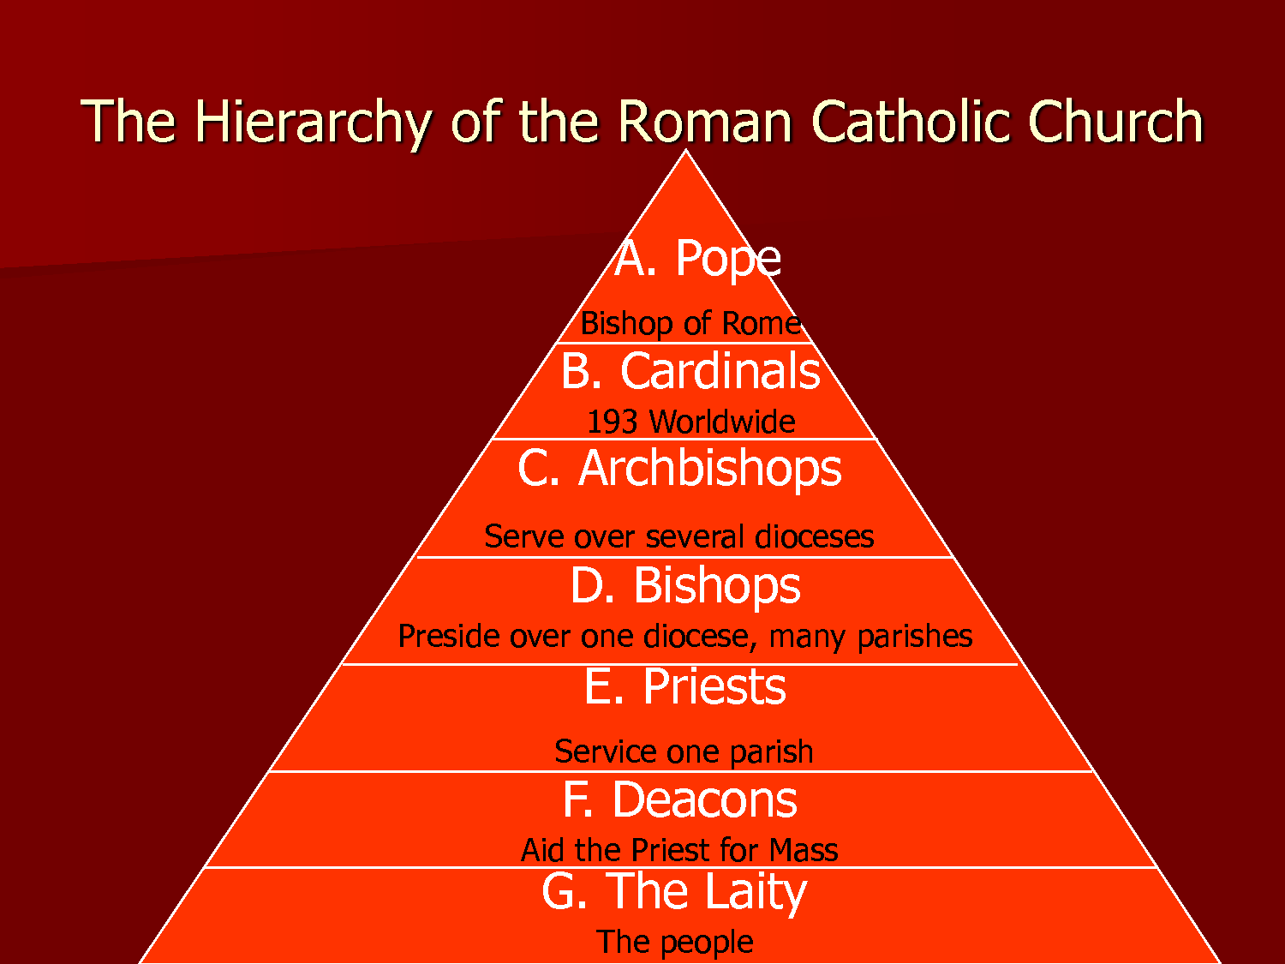
  - Developed a system of __________________
    - _____________ head local _____________
    - A group of parishes=________________
      - Headed by a ______________
    - A group of bishoprics=________________
      - Headed by an __________________
    - The __________________ came to claim he was the ____________ of the Roman ______________ Church (the ___________)
      - Based on the belief that ___________ gave __________ the keys to _______________
        - Peter=1st Bishop of Rome (1st ____________)
- Most ____________ Europeans accepted the pope as ___________, but his role was ______________
  - _______________________(590-604) extended the __________ of the papacy
    - Took _____________ control over __________ and surrounding areas (___________________)
      - Used Church ________________ to raise armies
        - Fought off the ________________ and the _______________
    - Extended his power within the Church
    - ________________ non-Christians through the __________________ movement
- ___________ separate themselves from _____________, everyday life to ____________ themselves to _______
  - _____________________=living the life of a monk
  - 6th C- ____________________ founded an order
    - Divided the day into ______________
      - Emphasize ______________ and physical _____________
      - All aspects of _________________ life were __________________
        - An ____________ (“father”) ruled each Benedictine ___________________
    - Took a vow of poverty
      - Became the _____________ of Christian civilization due to their commitment
    - Became the _________________________ of society
    - Monasteries became __________________ centers of __________________
  - Monks would spread __________________
    - _________________= people sent out to carry a ____________ message
- Women
  - Could become _________- dedicate their ___________ to God
  - Lived in ________________, headed by ________________
  - Many belonged to ____________ houses
    - Only way for women to receive an ________________
    - The abbess ______________ founded a monastery in Whitby in 657
      - Gave ________________ an important role
      - Educated _____ future __________________

Charlemagne and the Carolingians
- 7th century- _____________ kings lost their power
  - Chief ____________ of the king took _____________
    - ___________ assumed the throne
- Pepin’s son was __________________________ (________________)
  - He was a strong _______________ and ______________, and a devout ________________
    - He expanded the Frankish Kingdom into the ______________________ (______________ and _______________ Europe)
  - 800- he was crowned ________________________
    - Testifies to the _________________ nature of the Roman Empire
    - Symbolized the coming together of the _______________ and ________________ elements of society
      - The ____________ crowned him Emperor
- Charlemagne strongly supported _________________
  - Led to the ____________________________________ (____________)
    - Renewed interest in _________ culture and ______________ works (____________ and _______________)
    - _____________________ played an important role
      - Benedictine _____________ copied Christian and Latin __________________ in writing rooms, called ________________
      - Most of the ________________ works we have today exist because of these ___________________ monks

