RS Notes: The World of European Culture

Mannerism
- **________________** emerged in _____________ in the 1520 and 30’s
  - It broke down the values of ________________, _______________, ___________________, and ___________________
  - Elongated figures showed suffering, heightened __________________, and religious _______________
- _________________- portrayed elongated figures in unusual yellows and greens against a black background
  - The ____________ he depicts reflects the tensions created by the religious ________________ of the __________________.

The Baroque Period
- **_______________** replaced Mannerism.
  - Began in _______________ and was adopted by the ____________________________ movement.
  - Tried to join ________________________ ideals w/newly revived ___________________ feelings
  - Known for its dramatic effects that arouse ____________________
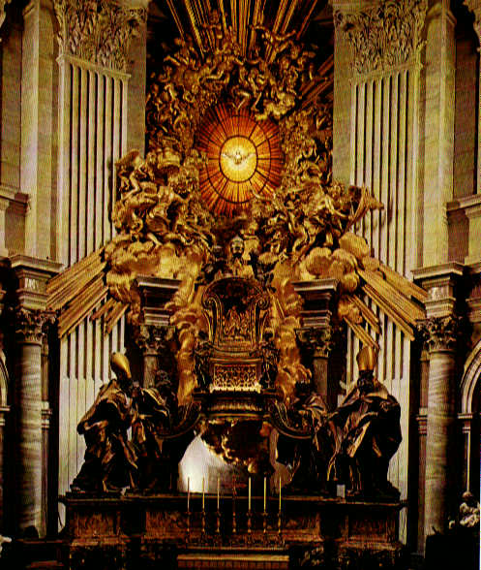
  - Baroque was used to show _________________, because the buildings became _________________ and ______________.
    - Ex. __________________

The Throne of Saint Peter
- __________________________________ completed St. Peter’s Basilica with a wooden “Throne of Saint Peter”
- It seems to _______________ in midair as rays of heavenly ____________ drive a mass of _____________ toward the spectator.

Golden Age of Literature
- ________________ had a cultural flourishing during ___________________ reign.
  - **___________________________**
    - Works performed at the ________________________
    - Actor and shareholder in _________________________________________ (Acting troupe)
    - Low admissions allowed ______________ classes to attend, but his plays appealed to people in __________ classes.
    - He is viewed as a universal _______________
      - Used masterful _________________ and showed deep _____________ into human psychology.
- Spain
  - ________________________ wrote almost _______________ plays
    - Witty, charming, action-packed, and realistic.
  - ____________________________________________- Don Quixote
    - Don Quixote- _______________ w/ lofty ______________
    - Sancho Panza- fat, earthly _______________ (sidekick)
      - Each come to value the other’s perspective
      - _____________ and __________________ are necessary to achieve

Political Thought
- ____________________________- Leviathan
  - Before society, there was a “__________________________”
    - Life is _________________ and _________________ because human nature is ________________________
    - To keep people from _____________________ each other, we need gov’t with an ________________ ruler
- ____________________- Two Treatises of Government
  - Before society, people lived in __________________ and ___________________, not violence and war
    - People had **_____________________ **(______________________________)
    - They had trouble protecting those rights
      - Establish _____________________ to protect rights
      - ____________________ between people and gov’t establishes __________________ obligations
        - If it’s broken, the people have the right to overthrow the gov’t
  - His ideas were important in the _________________ and _________________ Revolutions.
    - Used in the ________________________________ and _________________________________

