RS Notes: Southern Europe
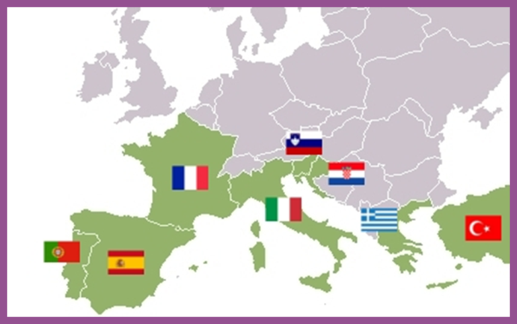
Population Patterns
- The People
  - Italians- come from ancient ___________, __________, etc.
  - Spanish- _____________ (prehistoric people)
  - Andorrans- _______________ (speak Catalan)
  - Greeks- _____________ and ___________________
  - Portuguese- homogenous mix of early _______________ groups
- Density and Distribution
  - The most ____________________ areas:
    - ____________ (Vatican City), Athens, ______________, Milan, _____________, Lisbon

History and Government
- Early History
  - Two early _________________ laid the foundation of ______________ Europe
    - Greeks- peak=_______________ BC
      - Formed ________________- linked by _________________ and _______________
      - Athens introduced idea of _________________
    - Romans-peak= _______________________
      - ___________________ became the official religion of the ____________ shortly before its fall in the ____________
        - The _______________ half of the empire survived and became the __________________________
          - Capital= ___________________
      - Germanic groups that __________________ Rome established separate ____________
        - Kept __________________________
      - Italy remained _________________ for hundreds of years
    - 711- Muslim group (__________) settled in Spain
  - The Renaissance was Europe’s ____________ of ___________ and __________________ achievement
    - Began in __________ in the 1300s
      - __________ and ______________ of Italian states gave some the ____________ to study and pursue new ways of ______________
        - These ___________ and _______ would spread across the _______________
  - 1400s- Europeans began to _____________ throughout the world
    - 1500s- ____________ and ________________ became wealthy from their colonies in the ___________________
- Winds of Change
  - __________ and __________ brought dramatic __________________
    - Increased _________________, _____________________ movements, civil wars, _______________, and __________________ marked this period
      - Spain and Portugal _________ much of their _____________ overseas
      - Greece won ___________________ from _______________
      - Italy became _________________ in the ____________
  - World Wars
    - Much of the _______________ of the world wars took place in ________________
      - ____________ remained ___________ (civil war in the ___________)
        - Allied with Western _______________
    - Greece was ruled by a _________________________ from 1967-1974
  - Today Southern Europe has _________________________ elected gov’ts
    - Members of the _________

Culture
- Education and Health Care
  - Literacy rates are above _______%
    - Strong gov’t _____________ of education
    - __________________ for all _______________
    - ________________ education is more common
  - Health care ___________ from country to country
    - Spain has more ________________ per ________________ than many other countries
    - _____________, however, has been less successful
    - Gov’ts fund all ______________ programs and provide other ____________________
- Language and Religion
  - __________________________ dominate the region
    - Derived from ___________
      - ___________, Spanish, ________________
  - Majority of the population in ____________, ___________, and ______________ are ______________
  - In Greece, they belong to the ________________________________
  - Italy and Spain have a growing _________________ population
- Arts and Leisure
  - Ancient _____________ and ________________ developed basic _____________________ elements
    - _____________, _____________, and ______________
  - Most of the ______________ works of art come from Southern Europe
    - __________________________ and ____________________ come from Italy
  - _______________ is the most popular sport in Southern Europe
  - _________________ is an important tradition in ____________ and _________________

