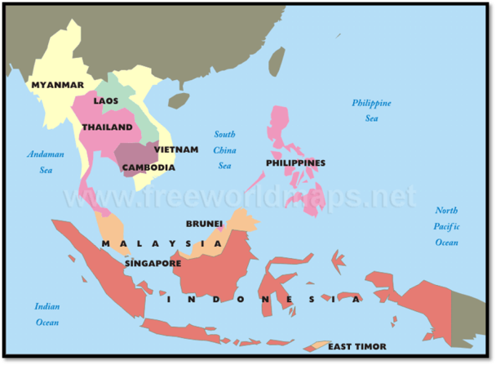
RS Notes: Southeast Asia

Southeast Asia
- Mainland=_____________, Vietnam, _______________, Myanmar, and Laos
- Islands=Malaysia, _______________, Brunei, Singapore, and ______________

History and Government- Mainland
- Early Civilizations
  - Early peoples were highly skilled _____________
    - _________=most important crop
  - Skilled in metal works
    - ________________ was first cast in ______________ around ________ BC
  - They worshiped ancestors, ______________, and natural spirits
- Kingdoms and Empires
  - Many civilizations developed on _________________
    - Became _______________ (sailors)
    - Gained wealth through ______________
- Western Colonization
  - By 1500’s, ________________ had arrived
    - Set up ________________________________________
    - Later gained SE Asia lands as colonies
      - _______________=only country to remain ____________
- Freedom
  - After ______________, fought for independence
    - By _____________, all had gained it
      - Some still suffered _________________
        - Myanmar’s military _____________________ its gov’t in the 80’s
          - Instituted ___________________- control and policing by military rules
- Vietnam War
  - 1954- ___________________ forces defeated the ________________
    - Vietnam was divided between ____________ (communist) and ____________ (non-communist)
      - US supported the ______________ (containment policy)
        - By ________- 2 Million Vietnamese and tens of thousands of ______________ were dead
        - US left and Vietnam was _______________ under a __________________ gov’t
- Cambodia
  - 1975- communist forces (_____________________) took over
    - Forced people out of _______________ and onto ________________
      - About 1 mil died from _______________, overwork, disease, or ________________

History and Government- Islands
- Colonization and Freedom
  - ______________________ claimed most of the islands
    - UK controlled Brunei and Singapore
    - US controlled the _____________________
  - Brought _________________ improvements
    - Replaced ____________ farms with ______________________________ farms
      - SE Asians worked for wages
  - ______________ occupied the islands in early _______ century
    - Philippines- about ____ mil died
      - US gave __________________ after WWII
    - After WWII – Europeans took over again
      - Insurrections led to ______________________
  - 1998- __________________ has moved towards a democracy
  - Brunei and Malaysia are __________________________________
Culture
- Education
  - Mainland- ____________________ is increasing
    - Gov’ts are working on _____________________ education
      - There is a shortage of _________________ and ______________, however.
  - Islands- education and quality of ___________ is increasing
    - Most children in _______________ attend primary school
      - Literacy=______% (Indonesia and Malaysia)
      - ______% in Philippines, Singapore, and Brunei
- Language and Religion
  - Hundreds of ___________________ and _____________________
    - Most stem from _______________________ and _____________________
    - Many speak languages of their ___________________, as well
  - Nearly all of the major _________________ are practiced in SE Asia
    - Sometimes, they _______________ the religions
    - Islands- _____________ is a major religion
      - Indonesia is largest Islamic ______________ in the world
    - Majority of _______________ are _______________
- Leisure and Celebrations
  - Mainland- enjoy a variety of _____________ activities
    - Cities- museums, _________________, parks, __________________, night clubs
    - Rural- visiting ________________, celebrating family ____________________
  - Islands- very _______________
    - Singapore- __________ culture is based on modern mass __________________
    - Most popular sport=____________ and ________________
    - Celebrations include religious and national holidays
      - _______________________ and _____________________ are observed by most on the islands

