RS Notes: The Scientific Revolution

How did thinking change?
- Medieval scientists did not make observations
  - Looked at the works of Aristotle for knowledge
- Renaissance thinkers studied newly discovered works of Ptolemy, Archimedes, and Plato
  - Learned that some had disagreed with Aristotle
  - Tried to reconcile the differences
- Technical problems, like determining how much a ship could carry spurred a movement towards observation and experimentation.
  - New instruments, like telescope and microscope, will make these experiments possible
- They used mathematics to lead these experiments

Astronomy
- Born in 2nd Century AD, Ptolemy was antiquity’s greatest astronomer
  - Ptolemaic system= geocentric model of the universe
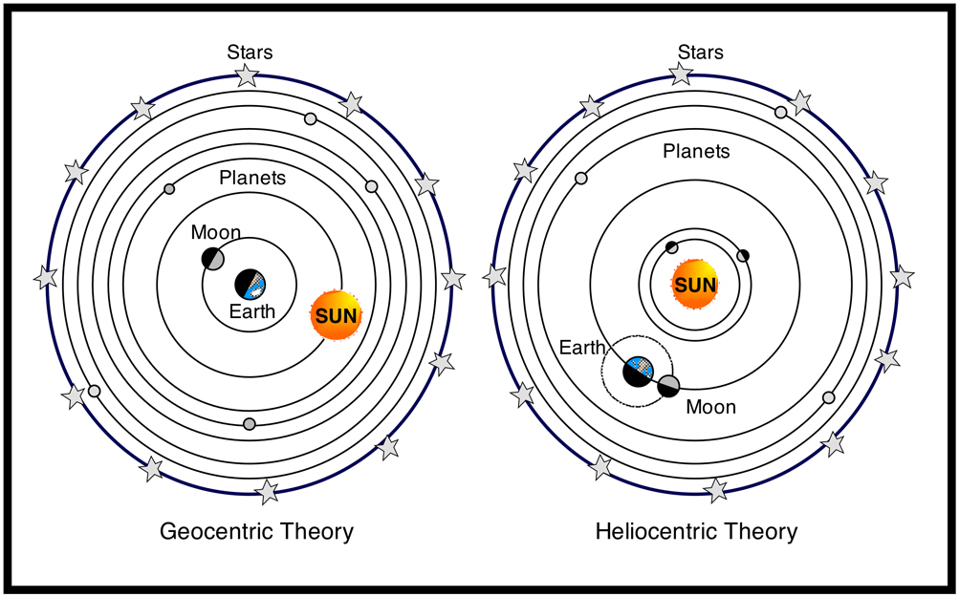
    - Earth (motionless) is in the center
    - Planets are different crystal-like spheres
    - 10th sphere=prime mover
      - It moves, so everything inside its path moves
    - Beyond this, is Heaven
- Nicholas Copernicus believed in his heliocentric system
  - Sun is in the center
  - Planets revolve around the sun, the moon around the Earth, and Earth rotates on an axis
- Johannes Kepler helped to destroy the Ptolemaic system
  - Observations confirmed the sun was the center
  - Tracked elliptical orbits of the planets
    - Ptolemy said they were circles
- Englishman Isaac Newton responded to one of the questions for the new model of the universe: What explains motion in the universe?
  - He defined 3 laws of motion
  - Crucial to his view is the universal law of gravitation
    - Every object in the universe is attracted to every other object by a force called gravity
    - This explained why planetary bodies did not go off in a straight line, but traveled in elliptical orbits
  - This dominated the worldview until Einstein’s Theory of Relativity
- Galileo Galilei answered the other question for the new astronomy: What are the planets made of?
  - He made regular observations using a telescope
    - Saw mountains on the moon and moons orbiting Jupiter
  - Ptolemy said they were made of light, but now it seems they are made of material

Galileo vs. The Church
- Galileo’s work began to make Europeans aware of the new view of the universe
  - He got into trouble with the Catholic Inquisition
    - The Pope ordered him to abandon the new system
    - Copernican model contradicted that of the Church and the Bible
      - The heavens were not spiritual but material, and God was no longer in a specific place
      - Most astronomers, however, believed the new model was correct

