RS Notes: The Scientific Revolution

How did thinking change?
- Medieval scientists did _______ make observations
  - Looked at the works of ______________ for knowledge
- _______________ thinkers __________ newly discovered works of ____________, Archimedes, and _________
  - Learned that some had ______________ with Aristotle
  - Tried to ________________ the differences
- Technical _____________, like determining how much a ________ could carry spurred a ________________ towards observation and _______________________.
  - New instruments, like ______________ and ______________, will make these experiments possible
- They used ___________________ to lead these experiments

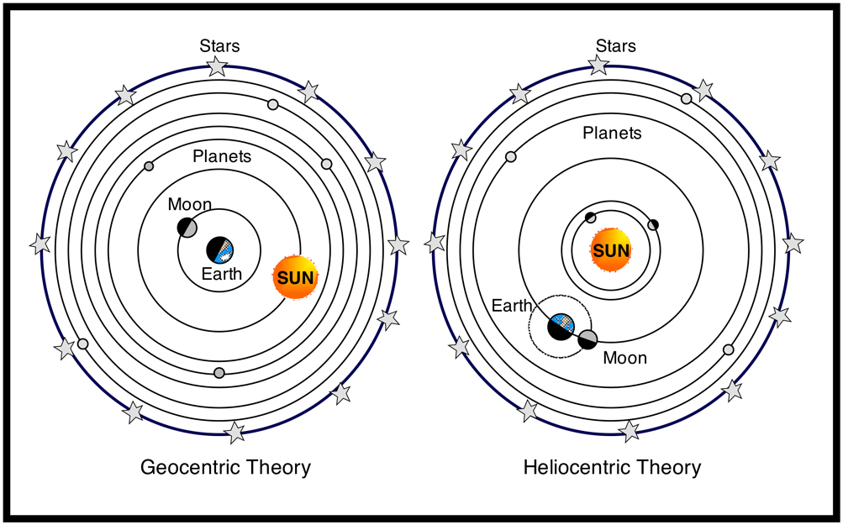
Astronomy
- Born in 2nd Century AD, ____________ was antiquity’s greatest astronomer
  - Ptolemaic system= _______________ model of the universe
    - Earth (motionless) is in the _____________
    - Planets are different crystal-like _______________
    - 10th sphere=____________________
      - It moves, so _________________ inside its path moves
    - Beyond this, is _______________
- __________________________ believed in his ___________________ system
  - Sun is in the _____________
  - Planets ___________ around the sun, the __________ around the Earth, and Earth rotates on an ______
- _________________________ helped to destroy the Ptolemaic system
  - Observations __________________ the sun was the center
  - Tracked ______________ orbits of the planets
    - Ptolemy said they were ________________
- Englishman _____________________ responded to one of the questions for the new ________ of the universe: What explains _____________ in the universe?
  - He defined ___ laws of motion
  - Crucial to his view is the _____________________________________
    - Every object in the universe is ______________ to every other __________ by a force called ______________
    - This explained why _____________ bodies did not go off in a ____________ line, but traveled in elliptical _____________
  - This dominated the __________________ until Einstein’s Theory of ________________
- __________________ answered the other question for the new astronomy: What are the __________ made of?
  - He made _____________ observations using a ________________
    - Saw ________________ on the moon and moons orbiting ______________
  - Ptolemy said they were made of __________, but now it seems they are made of _______________

Galileo vs. The Church
- Galileo’s work began to make _______________ aware of the new view of the ______________
  - He got into ______________ with the _________________________
    - The __________ ordered him to abandon the new system
    - Copernican model _______________ that of the Church and the ___________
      - The heavens were not _____________ but ________________, and _________ was no longer in a specific place
      - Most _________________, however, believed the new ____________ was correct

