RS Notes: Reaction and Revolution
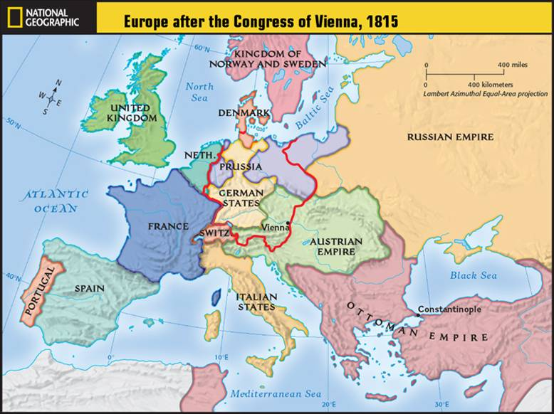
The Congress of Vienna
- After _______________ Wars and dissolution of the _________ ________________, European lines had to be _______________.
- Goal: Restore ___________________ to the old order (aka: ______________________)
  - Great Britain, Russia, Austria, and Prussia met
  - _________________________ European borders
    - Keep one country from ______________________ Europe
    - For example, _______________________ gained land because of _________________ gains

Conservatism, Liberalism, Nationalism
- ________________________= based on _________________ and social ____________________
  - Most favored _______________________ to political authority
  - ______________________ is crucial to society
  - Hated __________________________!!
- _______________________= people should be as ________________ as possible from government __________________.
  - Believed in ___________________________ principles
  - Religious ______________________, written _________________________, Bill of Rights, etc.
  - Connected to __________________________ men
    - should hold ________________________ to vote
- ________________________= cultural identity of a __________________ based on ________________, ____________________, ___________________________.
  - People should be loyal to the _________________________
    - Not necessarily a particular _____________________ or other political ______________
  - Became a _________________ to the existing political order
    - If ____________________ united, the balance of ________________ set up at the Congress of Vienna would be _____________________
    - _________________________ tried to suppress nationalism

Another French Revolution?
- _________________________ problems and middle class _____________ wanting to vote _______________ another French Revolution
  - Louis-Philippe refused to ________________________
- Monarchy ___________________________ in 1848
  - Provisional gov’t set up ______________________________________________________
    - ___________ men can vote!!
    - Provided work for the __________________________
      - Ran out of ______, so they __________________ it
      - Workers ran to the streets and rioted- thousands ________________
- Ratified a new ________________________________- A ______________________
  - Elected a single ______________________ and a ________________________ (__________________________)

Unification of Italy
- 1850- ______________________ dominant power in _______________________
  - People looked to ________________ (in N. Italy) to lead the charge- had ______
- Prime Minister- Camillo di Cavour- allied with ____________________
  - Provoked _________________ into declaring war
- Conflict result: Piedmont an _________________________________ state
  - This _____________________________ others to _________________ their states to Piedmont
- S. Italy- ______________________________________ raised an army
  - _________________________- Color of uniform
- _______________________ broke out in _________________________________________________ against the ________________________ Dynasty
  - Sicily and Naples
- Garibaldi jumped in and took control of _________________ and ____________________
  - Turned conquests over to __________________
- King of Piedmont became the ____________________.
- Full unification meant that they needed ____________________ (Austria) and __________________ (France)
  - They allied with _____________________ in the Prussian-Austrian War
    - Prussia gave them _____________________________
  - ____________________ left Rome in 1870

Unification of Germany
- Before 1871- Germany made up of many ____________________ states
  - Had a good ___________ system, industries, and ________________________ for a prosperous state
- 1862- ____________________________ named Prime minister of Prussia
  - Focused on ________________ affairs
  - Fought a war with Austria over ____________________ and ___________________
    - Prussia administered Schleswig, Austria- Holstein
      - He’ll use this as an ___________________ to fight again
- Seven Weeks War (1866)
  - Bismarck picked a fight with ___________________ & won
    - ______________________ given to Prussia
    - __________________ to Italy
    - North German Confederation- States north of ___________________ unified
- Franco Prussian War (1870-71)
  - Bismarck knew if they could ______________ France, German _______________ would agree to unity
  - July 1870-Bismarck doctored a __________________ that Wilhelm I (King of Prussia) insulted the French Ambassador
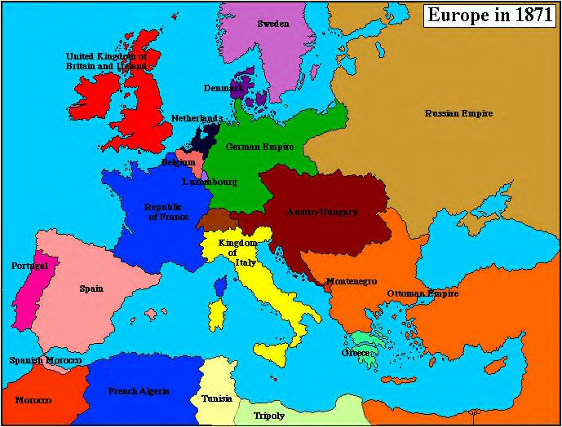
    - France __________ by September

Results of the War
- Wilhelm declared _____________________ (emperor) of Germany
- France lost Alsace & Lorraine
- Europe redrawn with new states of ________________ and _____________________
  - Germany- conservative with lots of ___________________ and _________________
- ______________ and ___________________ weakened

