RS Notes: Exploration- The Portuguese and Spanish Phase

Motives
- God, Glory, and Gold:
  - God= _____________ motives (spread Christianity)
  - Glory= _____________ motives (more power and land)
    - Adventure and myth- Fountain of Youth
  - Gold= ______________ Motives (make money)
- Technology made exploration possible
  - Ships are ____________ and more maneuverable
  - Magnetic compass- find ____________
  - Astrolabe- used to observe ______________ of stars
  - Quadrant- measure _______________ of heavenly bodies
  - Maps- map-making improved

Portuguese Exploration
- Prince Henry the Navigator
  - Hoped to discover ________________ Christian empire by sailing around Africa (conducted research along the way)
- Early Explorations & Discoveries
  - As they moved down the coast of ___________, they brought back ________ and __________
  - Bartholomew Diaz- rounded Cape of __________________
    - Opened the way for water voyages to Asia
  - ______________________- 1st European to reach ___________
    - Trading ___________ quickly established in India
    - 1st trip, Da Gama made ______x his initial investment
  - Discovery of Brazil-1500
    - ___________________________discovered it when his ship to India veered off course

Spanish Exploration
- Christopher Columbus-1492
  - Wanted to prove that it was _________ miles to ___________ (going west)
  - Queen ____________ of Spain sponsored him
  - Mid-October 1492- he landed on ____________________
    - Made ___ more voyages and found all of the islands of the Caribbean
- Treaty of Tordesillas
  - 1493- To avoid ______________, the pope divided the “discoveries” between ___________ and __________________
  - 1494- Moved the line west (gave Portugal claim to _______________)
- Magellan
  - 1st to ______________________ (travel around) the globe
  - Left ______________, Spain in Sept. _________
  - Reach Straits of __________________ (Southern tip of S. America) that October
  - He and 40 crew members _________ in __________________- March 1520
    - Rest of crew went to ______________________
  - Limped into Seville in 1522
    - Demonstrated that the ________________ was possible
    - 1 single ___________ of spices paid all the expenses of the entire ________ year voyage

The “New World”
- Conquistadors
  - Most advanced & complex civilizations in Central & South America=___________ & ____________ (Mexico) and the _____________ (Peru)
  - Conquistadors = adventurers & soldiers of ____________ on a quest for _____________ conquered these civilizations
    - ____________________ = 1519: led 600 men, 17 horses, a cannon, & some muskets
      - Eventually took the _______ with 800 more Spaniards & 25,000 native allies; Aztecs ___________________ in 1521
    - Francisco Pizarro & the Conquest of the Incas
      - Invaded _________ with only 180 men, 27 horses, & 2 cannons
      - Incas had _____________ overconfident troops who thought the “white men’s” ______________ were ________________
      - Incan ruler Atahualpá _______________, then ____________; many natives slaughtered
        - Empire fell apart without Atahualpá

Impact of Colonization
- Spain’s American Empire
  - _________________ = idea that colonies existed for the ____________ of the mother country
    - Colonies provided raw ____________, food, ______, & silver; transported only on Spanish ships
    - Spain sold finished (________________) goods back to the ___________
- Social & Economic Impact of Colonization
  - Changes in society:
    - Indians placed under new forms of _____________________
    - Required to speak a new _______________
    - Converted (usually by coercion) to a new _________________
    - _________________ practically destroyed
    - _________________ & _________________ by a new labor system
  - South American slaughter:
    - Death of _________________ of natives
    - Murder & carnage of conquest & subjugation
    - Work conditions = long _____________ in hot sun or below ground in dangerous mines
    - Disease = epidemics such as __________________ (no immunity to European diseases)
- African slavery:
  - 16th century = Africans ____________ & ____________ to replace native populations who were ___________ off in mines & on plantations
- Economy of the empire:
  - Most important = _________ & _____________ of Mexico & Bolivia
  - Other: sugar, tobacco, coffee, & cotton
- The Pacific trade:
  - Centered in ________________ (link between Spanish America & Orient)
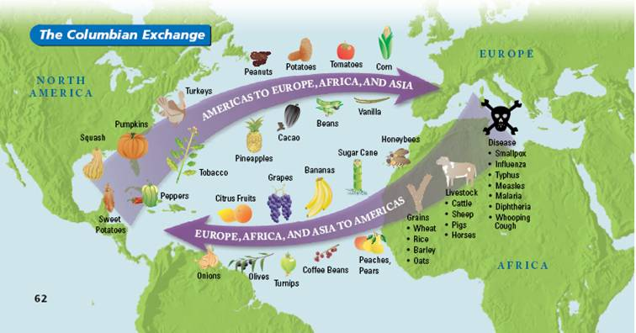
  - Main product: ____________

