RS Notes: Middle Ages Review

- What is the Magna Carta?

- What impact does it have on our system of government?

- What role did monks/nuns play in medieval society?

- Complete the feudal pyramid:
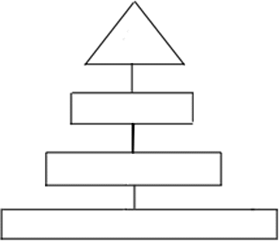

- What is the bourgeoisie?

- Why did popes and kings not get along?

- Complete the diagram:

Crusades

