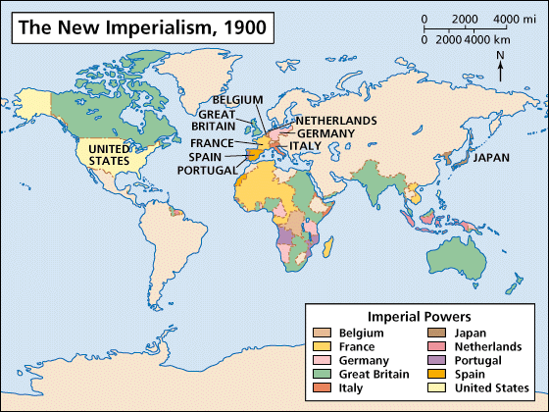
RS Notes: Imperialism Around the World

Motives for Imperialism
- Imperialism= ___________ of a nation’s power over other ___________
- Motives:
  - _____________- make money, expand foreign trade, create new markets, get resources
  - _____________- gain power, compete with other countries, expand territory, gain prestige
  - _____________- spread Christianity, moral values, educate people
  - _____________- explore the unknown, conduct scientific research, go on an adventure
  - _____________- “White Man’s Burden”- civilize the heathens, Social Darwinism (only the strong survive)
Asia
- 1900- Virtually all of SE Asia was under _________________ control
  - US- __________________ (Spanish-American War)
- China limited trade to one port: Guangzhou
  - Britain was ______________ more than exporting to China= trade imbalance
    - They began trading _____________ to China
      - Chinese gov’t wanted it stopped, Britain refused and won
        - _______________________- China opened _____ ports, gave Britain the island of _______________, and allowed Europeans ___________________________ (live by their own laws)
- 1886-1985- France, Russia, and Great Britain __________ land throughout ___________________.
  - ______________________________= areas where imperial powers had exclusive trading rights
- 1899- U.S. secretary of state, ______________, wrote notes to Britain, Russia, Germany, France, Italy, and Japan asking each country to respect equal trading rights in China (_______________________________)
- Japan was ___________________
  - US wanted them to _____________ ports, so they signed a ____________ that opened some
- Gov’t changes
  - Studied __________________ gov’ts to reform their own
    - Became a _______________, but it was ____________________, like Imperial Germany
      - New imperial ____________ created
      - New education system and more rights for the people
- Japan needed ________ materials and wanted to ___________________
  - Attacked China, Korea, and Russia
  - Japan led a successful surprise _____________ on the ________________ naval base at Port Arthur
    - Japanese ________________ defeated the Russian fleet
  - Some _____________________ began to fear the rise of Japanese power
    - 1907- President ___________________________ stopped Japanese immigration into the US
Africa
- Europeans used __________________ to gain land and nat. resources from Africans
  - GB, ______________, Germany, _______________, Italy, Spain, and Portugal competed to gain the most land
- West Africa- ______________ trade declined in late 19th C
  - Many __________________ resources (gold, ivory, etc.) & easy ports, so it was most desired area
- Central Africa-European explorers made the jungles of C. Africa interesting
  - ___________________________ of Belgium colonized the area
    - France ________________ to gain land in C. Africa
- Egypt was a part of the ____________________ Empire
  - ___________________________, an Ottoman military officer, took control and made an Egyptian state
- Europeans wanted to build a canal that connected the _____________________ and ____________ Seas
  - French completed the _________________________ in 1869
    - GB bought their share of the canal
  - GB put down a revolt- Egypt became a ___________________________ in 1914
    - GB seized Sudan in 1898
- At the 1884–1885 _________________________________, the major European powers divided up East Africa, giving recognition to German, British, and Portuguese claims
  - No African ___________________________ were there
- Most European __________________________ took place in S Africa (200,000 people)
  - Lots of ___________________ mines
- By 1914, only ____________________ and _______________________ remained independent
- ___________________________- GB relied on existing political institutions to govern
  - Interfered much less with indigenous ____________________ and __________________
    - Most decisions came from the parent country
- ___________________________- Most other nations used this
  - Set up their ____________ governments within the colony
    - This often ___________________ African _______________________
Latin America
- Creoles- descendent of _________________________
  - Controlled _____________ and ________________________
  - Attracted to principles of ______________________ of all people
- 19th Century- _______________________ wars gave creoles an opportunity
  - Napoleon overthrew monarchies of ___________ and _______________, weakening control of colonies
    - 1807-1825= series of _______________ enabled most of Latin America to become independent
      - Hispaniola- slave revolt led to independent ___________- first revolt
- The ______ and _______ protected the new independent states
  - ______________________- warned against European intervention in LA
- The US and GB now ____________________ LA
  - GB dominated ________________
  - US was their source for _____________________ money and loans
- US involvement in Latin America
  - Began intervening in LA by making ____________ a protectorate and annexing ____________________
  - 1903- built the ____________________________
  - Americans wanted to protect their investments in LA, so the US began using the ___________________
    - Many Latin Americans lost _____________ in the US
Effects of Imperialism
- Positive effects
  - Reduced local __________________
  - School systems created
  - Infrastructure created (______________, railroads, telephones, etc.)
  - Improved _____________________, nutrition, etc.
- Negative effects
  - Loss of control of _______________________ and economy
  - Economic pursuits brought __________________
  - Access to _______________________ and _______________________ destroyed
  - Increased taxes
  - European rule- degrading and insensitive to ___________________ culture
  - Most harmful: ___________________ of continent (esp. Africa) created problems

