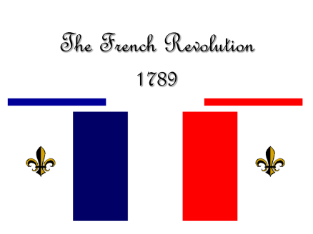
RS Notes: The French Revolution

Background to the Revolution
- Estates General:
  - Divided into ___ estates
    - 1st Estate= _____________ (.5%)
    - 2nd Estate= ____________ (1.5%)
    - 3rd Estate= ___________________ (98%)
  - Each estate gets ________ vote in the Estates General
    - 1 & 2 vote _____________, making 3 _______________
- King had absolute power in gov’t
  - ______________ and ___________________ (middle class) wanted power
    - Use ___________________ principles to gain power
- There are 4 causes of the revolution
  - _______________________________________________
    - Wars: 7 Years War, American Revolution
    - Royal luxuries (_______________ especially known for spending $)
      - King wanted to raise _____________ to fix this, but the country was going into an economic depression
  - _______________________________________________
    - ______________ had been abolished, but people still paid ____________ dues (relics of feudalism)
    - Living conditions were terrible
  - _______________________________________________
    - Only the _____________ Estate pays taxes
    - 98% is the _______________ in the Estates General
  - _______________________________________________
    - People should be free to ____________ gov’t officials.

Estate General -> National Assembly
- King _________________ needed to call the Estates General to meet to fix ______________ troubles
  - 3rd Estate wanted to vote with __________________ getting a vote
    - They had many _________ members than the other two
  - King used the _____________ method of voting (_________________)
    - So, the 3rd Estate ________________ from the gov’t
- They became the __________________________ and went to draft a _________________
  - They were _____________ out of their meeting place, so they went to a ___________________ to draft it
  - There, they promised to meet until it was drafted (____________________________)
- The king’s ___________ were going to attack the National Assembly, but many _________________ stepped in
  - They stormed the ______________
    - Royal ___________ and ______________ in Paris
  - The king’s authority collapsed
- The Great Fear
  - Many people felt _______________ by the revolution
    - They were scared it would _____________ them or their livelihoods
    - They were also scared that foreign ______________ would send troops to _______________ the king
      - They didn’t want this to happen in their countries.
    - _____________ were formed to ___________ themselves

Destruction of the Old Regime
- ___________________________________________________________
  - The National Assembly proclaimed ___________ and _____________________ for all men, access to public office based on talent, an end to ________________ from ______________.
  - All citizens have the right to _________________ in gov’t
  - Freedom of ____________ and _______________
    - Women would get these rights, but _________ be allowed to participate in gov’t (including voting)
- Women in the ______ got the right to vote in _______
- Louis XIV wanted to stay in __________________
  - Thousands of ___________ women marched there _____________ with pitchforks, swords, muskets, etc.
    - They _______ with him and told them about their _______________
  - They _______________ him and his family and _____________ them to ____________
    - Louis brought ___________ as a ________________ gesture
    - The __________ family was virtually held _______________ in Paris
- The ________________ was reformed too
  - _____________ were seized
  - Bishops and priests were to be ____________ by the ____________ and paid by the _____________
  - Many _________________ became __________________ of the revolution
- Constitution of 1791
  - Limited _________________ w/ _______________________ (made laws)
    - Only men over _______ who paid enough _____________ could vote
      - Only rich guys got in
- Many people _____________ the new order
  - Catholics, _____________, the _____________, royalists
  - The king tried to ____________, but was _______________ to Paris
  - Other monarchs (_____________ and __________________)
  - The Legislative Assembly _________ for the 1st time in ____________
    - Declared ________ on ________________, but lost
- Because of these factors, ________________________________ broke out
  - _____________________ organized a ___________ attack on the king and L.A.
    - Captured the ___________ and demanded an ________ to the ____________________.
  - _______________ went to the Paris Commune
    - Made up of ___________________ and the ____________ (______-________________= without fancy clothes)
  - The ___________________ was about to enter a more _______________ phase

