Fitzgerald/World History Name _________________________________
Total ( /60)

Middle Ages Exam

- a. Draw an illustrated dictionary entry for the term “Crusades.” (10 pts)
Definition:
______________________________________________
______________________________________________
______________________________________________
______________________________________________
______________________________________________
Synonym: _____________________________________
Illustration
Antonym: _____________________________________

b. Describe 4 effects of the Crusades. (4 pts)
Effect: _________________________________________________________________________________
Effect: _________________________________________________________________________________
Effect: _________________________________________________________________________________
Effect: _________________________________________________________________________________

- Explain how the following contributed to the end of feudalism. (6 pts)
- Crusades- ______________________________________________________________________________ _______________________________________________________________________________________
- Black Death- ____________________________________________________________________________ _______________________________________________________________________________________
- 100 Years War- __________________________________________________________________________ _______________________________________________________________________________________

- a. T or F (circle one): Charlemagne was important in the development of European society. (1 pt)

b. Justify your answer with specific examples. (3 pts)
____________________________________________________________________________________________________________________________________________________________________________________________________________________________________________________________________________________________________________________________________________________________________________________

- Explain the importance of the Magna Carta. [Hint: Include how it affects us today.] (5 pts)
____________________________________________________________________________________________________________________________________________________________________________________________________________________________________________________________________________________________________________________________________________________________________________________

- Explain the causes of disagreements between popes and monarchs in the Middle Ages? Why were they always fighting? (2 pts)

- ______________________________________________________________________________________________________________________________________________________________________________

Describe two situations where kings and popes disagreed.
** [Be specific!!! Explain what happened!! (Use names of popes and kings)] (8 pts)
- ____________________________________________________________________________________________________________________________________________________________________________________________________________________________________________________________________________________________________________________________________________________________
- ____________________________________________________________________________________________________________________________________________________________________________________________________________________________________________________________________________________________________________________________________________________________

- What was the Black Death? (3 pts)
__________________________________________________________________________________________________________________________________________________________________________________________
- How did it affect feudalism? (3 pts)
____________________________________________________________________________________________________________________________________________________________________________________
- How did it affect the Church? (3 pts)
____________________________________________________________________________________________________________________________________________________________________________________
- How did it affect the economy? (3 pts)
____________________________________________________________________________________________________________________________________________________________________________________

- Complete the Venn diagram by comparing the beliefs/practices of Christians, and Muslims. Include at least 3 areas of contrast each and 2 areas of comparison (8 items total). Label the diagram. (10 pts)
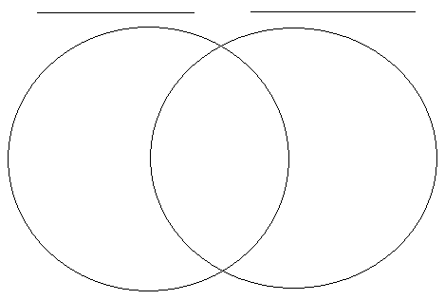

- What claim did each have to the Holy Land? Why do they think they should control it?
Muslims-___________________________________________________________________________________
Christians- _________________________________________________________________________________

