Teacher Name | Marya Runkle | School T. C. Williams
Subject Area | World History II | Grade/level 10

Adventure of the American Mind Northern Virginia
Alexandria Summer Curriculum Writing 2004
Lesson Plan Template

Title of Lesson | INFLUENCE OF THE ENLIGHTENMENT ON THE BEGINNING OF AMERICA
Unit Topic | THE ENLIGHTENMENT
Enduring  Understanding | As a result of this lesson, students will understand:  • Every government is based on founding principles that reflect the people and the time in which it was created  • Political philosophies are not created in a vacuum. They are based in the agreement or disagreement of other philosophers.
Content  Knowledge | As a result of this lesson, students will know:  • The influence of the Enlightenment philosophers(Hobbes, Locke, Montesquieu, Rousseau, Voltaire) on the following aspects of the origins of America  o The Declaration of Independence  o The Constitution  o The Bill of Rights
Skills | As a result of this lesson, students will be able to:  • Use primary source documents to discover philosophies and beliefs of a specific time period  • Skim a larger document to pinpoint specific information  • Synthesize information from a previous day’s learning to a new circumstance
SOLs addressed | WHII.6d – The student will demonstrate knowledge of specific,  political, economic, and religious changes during the sixteenth, seventeenth, and eighteenth centuries by explaining the political, religious, and social ideas of the Enlightenment and the ways in which they influenced the founders of the United States.
Length of  Lesson | 1-90 minute class period

Overview of  lesson | This lesson is an evaluation of student’s comprehension of the  beliefs, philosophies and writings of Hobbes, Locke, Montesquieu, Rousseau, and Voltaire. In pairs, students will examine the Declaration of Independence, The Constitution, The Bill of Rights and various artistic works of the time to determine how  Enlightenment philosophers influenced the American Revolution and the formation of the American government. The activity will culminate with an essay writing assignment for advanced students and a “brag sheet” writing assignment for general education students.
Prior  Knowledge | Students must have a working understanding of the basic  philosophies of Hobbes, Locke, Montesquieu, Rousseau, and Voltaire. They must also have a basic knowledge of the “story” of the American Revolution (Grade 8 Virginia curriculum).
Resources  needed | Hobbes Leviathan  http://www.loc.gov/exhibits/world/images/s37.jpg  Text of Declaration of Independence: http://memory.loc.gov/cgi- bin/query/r?ammem/bdsbib:@field(NUMBER+@band(bdsdcc+021  01))  Tearing Down of the Statue of King George III  http://www.loc.gov/exhibits/declara/images/statue.jpg  Harper’s Ferry Boston Tea Party http://cdl.library.cornell.edu/cgi- bin/moa/pageviewer?coll=moa&root=/moa/harp/harp0004/&tif=  00011.TIF&view=50&frames=1  The Boston Massacre http://www.americaslibrary.gov/jb/revolut/jb_revolut_boston_1_e  .html  Text of US. Constitution: http://memory.loc.gov/cgi- bin/query/r?ammem/bdsbib:@field(NUMBER+@band(bdsdcc+c08  01))  OTHER RESOURCES  Flags of the American Revolution http://www.americanrevwar.homestead.com/files/FLAGS.HTM  The Boston Tea Party http://classroomclipart.com/cgi- bin/kids/imageFolio.cgi?action=view&link=History/United_States/

American_Revolution/Boston_Tea_Party&image=BHOUS_156.jpg&
img=&tt=

Bill of Rights with National Archives http://www.archives.gov/national_archives_experience/charters/ print_friendly.html?page=bill_of_rights_transcript_content.html&tit le=NARA%20%7C%20The%20Bill%20of%20Rights%3A%20A%20Tr anscription

15 Laminated Placards- (see attached document) Student Worksheet – (see attached document)
Process of  lesson | Preview:  • Display the cover of Hobbes Leviathan in front of the classroom  • Ask students to answer the following questions  o List the things you see in this picture (do not make any guesses or interpretations).  o What do you think is the message of this picture?  o Which of the five Enlightenment philosophers we  studied yesterday would agree with the message of this  picture.  Process:  Entry Level Assessment of the American Revolution  1. Write the phrase “American Revolution” on the board. Ask students to shout-out any words that come to mind when they see this phrase.  2. Discuss any questions or misconceptions students might have as you generate the word splash.  3. Explain to students that they are going to be investigating how the Enlightenment influenced the words, ideas, and things up on the board.  Main Activity  1. Divide students into pairs and have them arrange their desks appropriately.  2. Pass out the student assignment sheet titled “Influence of the  Enlightenment on the Beginning of America”  3. Review the assignment sheet and answer and questions.  4. Teacher will then go to the table with the placards and ask the students to begin  5. One person from each pair will come up and get a placard.

They will then return to their pairs, review the placard and
answer the questions on the activity sheet that pertain to the placard.
6. The pair will come up to check their answers with the teacher.
If the answers are correct they will receive a smiley face and then choose another placard. If the answers are not complete or incorrect the teacher will guide the students and ask them to return to their seats to complete or find the right answer.
7. When most of the groups are completed ask students to finish the placard they are using and return to your table for a final check off.
8. Explain evaluation. Please see evaluation section for final steps.
Evaluation | Students will write an essay that answers the following question:  How did the ideas of the Enlightenment influence the American  Revolution and the formation of the American government?  (See attached essay assignment sheet and rubric.)
Extension  Activities | • Students can create and act out a talk show that interviews the Enlightenment philosophers to determine who had the MOST influence on the founding of America.  • Students can participate in a debate to determine who was the most influential philosopher of the Enlightenment  • Students can visit the National Archives to see the original copies of the Declaration of Independence, Constitution and Bill of Rights.
Possibilities for  Differentiation | • Instead of an essay, some students would be more successful with the Brag Bubbles exercise. Students will be given sheets with the pictures of the Enlightenment philosopher and quote bubbles for each. Students will then fill in the bubbles by writing how the philosopher influenced the founding of America.

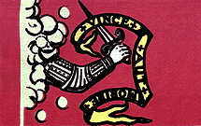PLACARD 1

Bedford Flag

This flag was present at the battle of Concord in April 19, 1775. It was carried by Nathaniel Page, a Bedford Minuteman. The Latin inscription "Vince Aut Morire" means "Conquer or Die". The arm emerging from the clouds represents the arm of God. The original can be seen at the Bedford Town Library.

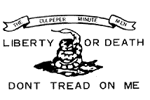PLACARD 2

CULPEPER FLAG

This flag represented a group of about one hundred minutemen from Culpeper, Virginia. The group formed part of Colonel Patrick Henry's First Virginia Regiment of 1775. In October- November 1775 three hundred such minutemen, led by Colonel Stevens, assembled at Culpeper Court House and marched for Williamsburg. Their unusual dress alarmed the people as they marched through the country. The word "LIBERTY OR
DEATH" were in large white letters on the breast of their hunting shirts. They had bucks' tails in their hats and in their belts,
tomahawks and scalping knives.

PLACARD 3

Washington Cruisers Flag

This flag was used by George Washington on his squadron of six schooners which he outfitted at his own expense in the fall of 1775. This flag was a variation of the New England Pine Tree
flag. It was later modified and adopted by the Massachusetts Navy. The Sons of Liberty would rally under a large tree, in Boston Massachusetts, which came to be known as "The Liberty Tree". This tree became a symbol of American independence.
Knowing they were up against a great military power they believed they were sustained by still a greater power, thus their "APPEAL TO HEAVEN".

PLACARD4

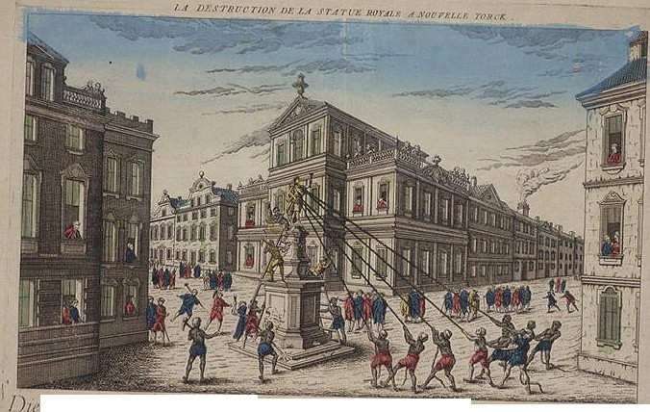et; f/OI'l'!!fl, rler konj:;_hi·hm
, llllt '-Y..t Neu '(r,,.l'k

lh/J f.a lJ,vfrttdrot/l(h<lf1 ,)/ditl! '!!Yak )
(/ ,\lotJI/11!111' ro,.,.l ./

DESCRIPTION ON THE BACK
,._.- .-- 'f.l'•... "' _,
•""- • •I

A print of the destruction of the statue of King George III in
New York City following the reading of the Declaration of Independence to the American army, July 9, 1776.

Before July 9, 1776 an equestrian statue of King George II stood menacingly on Bowling Green in New York City. The King George statue was cast in lead and gilded, shipped to America, and erected at Bowling Green, near the tip of Manhattan on Aug. 21, 1770. This was the birth date of the king's late father, Prince Frederick. The statue was massive estimated at
4,000 pounds. The king was depicted on horseback, in Roman garb, after the style of the equestrian statue of Marcus Aurelius in Rome.

The statue quickly became unpopular with the public, and in 1773 an anti-graffiti, anti- desecration law was enacted to discourage vandalism.

After the early battles of the Revolution, the Americans began to covet the 4,000 pounds of lead towering above them. On the night of July 9, 1776 - when the Declaration of Independence was received and read in New York City - the statue met its demise. In a burst of patriotic fervor, a number of soldiers, sailors and citizens decided to act. They threw ropes around it, succeeded in pulling it down, and cut it into pieces of manageable size.

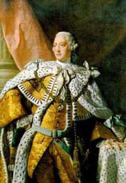PLACARD 5

Painting of King George III

(The King who lost the American Colonies)

King George III sat upon the throne of England from 1760-1820. It was on his watch that the American colonies were lost. King George III, after the French and Indian War, had large debts to pay, and thought he could extract the necessary money from the colonies. King George was incensed when the insolent American colonists objected to the taxes being levied, particularly the Stamp Act. When the Stamp Act was repealed, King George flew into a rage. King George thought the colonists should be dealt with harshly for their disobedience and insolence. Using his profound influence, he pushed through the Townshend Acts, in 1766, taxing many commodity items including tea resulting in the infamous Boston Tea Party. King George was eventually humbled as the American colonies successfully became the United States of America. America's success and King George remained embroiled in one conflict or another for many years.

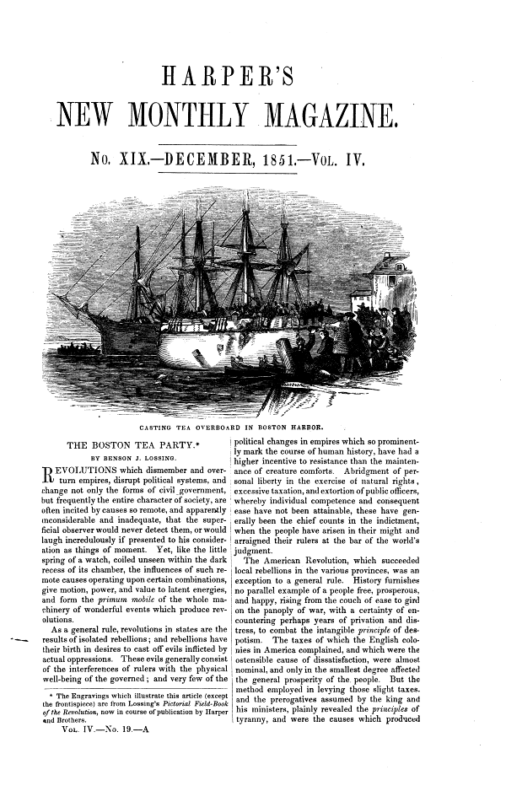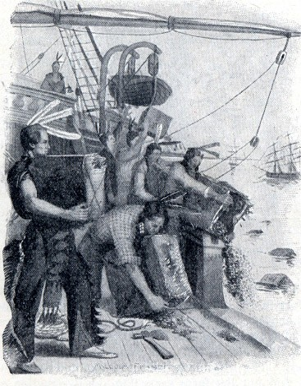PLACARD 6: The Boston Tea Party

As a protest against a tax placed on imported tea by the British crown, a group of American colonists, led by Samuel Adams, staged the Boston Tea Party. On December 16, 1773, the colonists, some dressed as Native Americans, boarded three British ships and tossed the tea cargo into Boston Harbor.

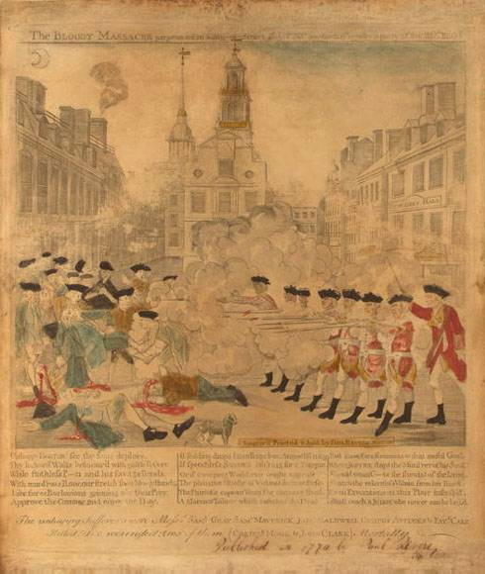PLACARD 7

The Boston Massacre

March 5, 1770

Tensions between the American colonists and the British were already running high in the early spring of
1770. Late in the afternoon, on March 5, a crowd of jeering Bostonians slinging
snowballs gathered around
a small group of British soldiers guarding the Boston Customs House. The
soldiers became enraged after one of them had been hit, and they fired into the crowd, even though they were under orders not to
fire. Their shots hit and killed four civilians in an event that has come to be known as
the Boston Massacre.

PLACARD 8

The Declaration of Independence

When, in the Course of human Events, it becomes necessary for one People to dissolve the Political Bands which have connected them with another, and to assume, among the Power of the Earth, the separate and equal Station to which the Laws of Nature and of Nature’s GOD entitle them, a decent Respect to the Opinions of Mankind requires that they should declare the Causes which impel them to the Separation.

PLACARD 9

The Declaration of Independence

We hold these Truths to be self-evident, that all Men are created equal, that they are
endowed, by their CREATOR, with certain unalienable Rights,
that among these are Life, Liberty and the Pursuit of Happiness.

PLACARD 10

The Declaration of Independence

That to secure these Rights, Governments are instituted among Men, deriving their just Powers from the Consent of the Governed,
that whenever any Form of Government become destructive of these Ends, it is the Right of
the People to alter or to abolish it, and to institute new Government, laying its Foundation on such Principles, and organizing its Powers in such Form, as to them shall
seem most likely to effect their
Safety and Happiness.

PLACARD 11

The Declaration of Independence

The History of the present King of Great-Britain is a History of repeated Injuries and Usurpations, all having in direct Object the Establishment of an absolute Tyranny over these States

PLACARD 12

WETHE PEOPLE
OF THEUNITED STATES OF AMERICA, IN ORDER TO FORM AMORE PERFECT UNIO
ESTABLISH JUSTICE, INSUREDOMESTIC TRANQUILITY PROVIDEFOR THt COMMONDEFENC£, PROMOTHE GENERAL WELFAF{E,
AND SECURE THE BLESSINGS OF LIBERTY TO OURSELVES AND OUR POSTERITY,
DO ORDAIN ANDESTABLISH THIS

CONSTITUTIONFOR THE UNJTED STATES OF AMERICA.
- 'ro
1\t-

PLACARD 13

The Constitution

Article I: ALL legislative powers, herein grated, shall be vested in a Congress of the United States, which shall consist of a Senate and House of Representatives.

Article II: The executive power shall be vested in a President of the United States of America. He shall hold his office during the term of four years, and , together with the Vice-President, chosen for the same term.

Article III: The judicial power of the United States shall be vested in one Supreme Court, and in such Inferior Courths as the congress may from time to time ordain and establish. The Judges both of the supreme and Inferior Courts, shall hold their offices during good behaviour; and shall, at stated times, receive for their services a compensation, which shall not be diminished during their continuance in office.

PLACARD 14

The Constitution

The Senators and Representative before mentioned, and the members of the several State Legislature, and all executive and judicial officers, both of the United States and of the several States, shall be bound by oath or affirmation to support this Constitution; but no religious test shall ever be required as a qualification to any office, or public trust, under the United States.

PLACARD 15

The Bill of Rights

Amendment I: Congress shall make no law respecting an establishment of religion, or prohibiting the free exercise
thereof; or abridging the freedom of speech, or of the press; or the right of the people peaceably to assemble, and to petition the Government for a redress of grievances.

INFLUENCE OF THE ENLIGHTENMENT ON THE BEGINNING OF AMERICA

Materials you need to work:
• Pen/pencil
• Table of the beliefs of the Enlightenment philosophers from last class

Follow these steps to success:
• Step 1: Retrieve a placard (laminated piece of paper) from Ms. Runkle’s table and bring it back to your pair.
• Step 2: Describe what you see AND/OR summarize what you read on the placard while you take notes in the “Describe What You See Column” below.
• Step 3: Identify which (there may be more than one) Enlightenment philosopher we studied last class that influenced the actions, statements, or beliefs on the placard. Write their name(s) in the “Enlightenment Philosopher Who Influenced”.
• Step 4: Identify two pieces of evidence from the placard that PROVE the philosopher you identified influenced the information on your placard. Write your two pieces of evidence in the “Evidence” column.
• Step 5: BOTH partners see Ms. Runkle to check off your answer and retrieve another placard.

PLACARD # | DESCRIBE WHAT YOU SEE | ENLIGHTENMENT PHILOSOPHER | EVIDENCE
1
2
3
4
5
6

PLACARD # | DESCRIBE WHAT YOU SEE | ENLIGHTENMENT PHILOSOPHER | EVIDENCE
7
8
9
10
11
12
13
14
15

Take Home Essay Exam

Please answer the following question in a well-organized, thoughtful and original essay.

How did the ideas of the Enlightenment influence the American Revolution and the formation of the American Government?

Please include references to specific philosophers, documents and information and REMEMBER THIS WILL COUNT AS AN EXAM GRADE.

Your essay must:
• Be typed
• 12 pt font
• double-spaced
• no more than 1” margins
• a title
• Your name
• The date the assignment is due

PLEASE SEE THE RUBRIC ON THE BACK FOR MY GRADING CRITERIA!

ENLIGHTENMENT AND THE FOUNDING OF AMERICA

Name:
Date:

Grade: World History II
Teacher: Ms. Runkle

 |  | Criteria |  |  |  | Value
 | 4 |  | 3 | 2 | 1
Thesis Statement | Thesis statement is clearly stated, detailed and supported  throughout the entire essay. |  | Thesis statement is clearly stated, detailed and supported throughout most of the essay. | Attempt is made to include a thesis statement without sufficient support throughout the essay. | No thesis statement is present.
Content Knowledge | Clearly communicated answer to the question and demonstrates exemplary knowledge of the content. |  | Consistently communicated answer to the question and demonstrates satisfactory knowledge of the content. | Communicates a basic answer to the question and demonstrates minimal knowledge of the content. | Ineffectively communicates answer to the question and demonstrates limited knowledge of the content.
Conclusions  Reached | Student demonstrates full knowledge (more than required)with explanations and elaboration. |  | Student is at ease with content, but fails to elaborate. | Student is uncomfortable with information and is able to completely answer the question. | Student does not have grasp of information; student cannot answer question.
Supporting Details | All conclusions drawn are supported with specific detail, explained and properly identified. |  | Most conclusions drawn are supported with specific detail, explained and properly identified. | Some conclusions drawn are supported with detailand minimally explained. | One or few conclusions drawn are supported with detail, and little or no explanation is given.
Organization Of  Thought | Work is clearly orgainzed and easy for the reader to follow. |  | Work demonstrates some organization and is readable. | Disorganized apporoach tot he question with major obstacles to the reader's comprehension. | Lack organization of thought and reader cannot comprehend.
Communication | The final body of work was free of grammar, spelling, and formatting errors. |  | The final body of work had 1 error related to either grammar, spelling and formatting errors. | The final body of work had 3-5 grammar, spelling, and formatting errors. | The final body of work had major grammar, spelling, and formatting errors.
 |  |  |  |  | Total:-----

TEACHER COMMENTS ON THE BACK

