Fitzgerald/World History Name________________________
[Teacher Use Only: _________/57 pts]

Exam: Exploration and Absolutism
Write your responses to the following questions in complete sentences and in your own words.

- Draw an illustrated dictionary entry for the term “Absolute.” Include a definition in your own words, a synonym (word or phrase), an antonym (word or phrase), and a picture to illustrate your definition. (10 pts)
Definition:
______________________________________________
______________________________________________
______________________________________________
______________________________________________
______________________________________________
Synonym: _____________________________________
Antonym: _____________________________________
Illustration

2. List and describe three technologies that allowed Europeans to explore in the 15th and 16th centuries.
(6 pts)
__________________________= _____________________________________________________
__________________________= _____________________________________________________
__________________________= _____________________________________________________

3. a. What is mercantilism? (2 pts)
________________________________________________________________________________________________________________________________________________________________________________

b. How did this idea encourage more countries to expand their territory? (2 pts)
________________________________________________________________________________________________________________________________________________________________________________

4. Answer the questions after reading the document:

From a letter by Christopher Columbus, October 12, 1492
“ I gave to them some red caps, and to others glass beads, which they hung about their necks, and many other things of slight value, in which they took much pleasure…They all go quite naked as their mothers bore them. None of them more than 30 years old, very well built, of very handsome bodies and very fine faces. They ought to be good servants and of good skill, for I see that they repeat very quickly whatever is said to them.”
- Has been modified.

a. What qualities does Christopher Columbus describe in the Natives? (2 pts)
____________________________________________________________________________________________________________________________________________________________________

b. How does Columbus view his future relationship with “them”? (2 pts)
____________________________________________________________________________________________________________________________________________________________________

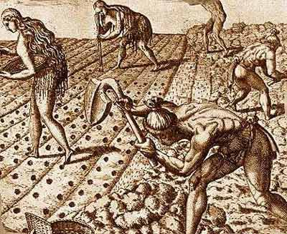
5. How does this image show the change in lifestyle experienced by the Native population when the Europeans declared the America’s as a colony? (3 pts)
____________________________________________________
____________________________________________________
____________________________________________________
____________________________________________________
____________________________________________________

6. Use the table to list the types of monarchies, as well as the countries that had that type of government in the 16th and 17th centuries. (5 pts)

Type of Monarchy | Countries

7. Describe the structure of the English government. (6 pts)
(Hint: Include all the branches of their government)
________________________________________________________________________________________________________________________________________________________________________________
________________________________________________________________________________________________________________________________________________________________________________

8. a. What is divine right of kings? (2 pts)
________________________________________________________________________________________________________________________________________________________________________________

b. How was this idea used to by kings? (3 pts)
________________________________________________________________________________________________________________________________________________________________________________

9. a. Using the table, describe the ideas of John Locke and Thomas Hobbes. (8 pts)

 | John Locke | Thomas Hobbes
Type of Government
Purpose of Government
Human Nature
Natural Rights

b. Whose ideas do you most agree with? Locke or Hobbes (circle one) (1 pt)

c. Support your answer with specific details. (5 pts)
________________________________________________________________________________________________________________________________________________________________________________
________________________________________________________________________________________________________________________________________________________________________________
________________________________________________________________________________________

